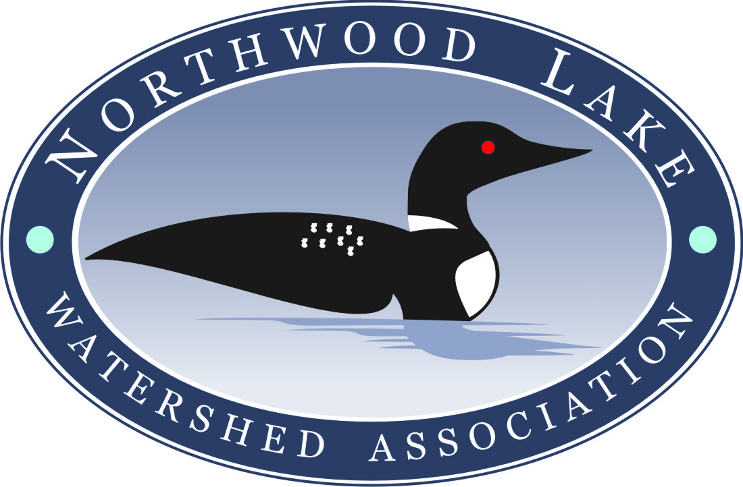
P.O. Box 152, Northwood NH 03261

It's summer, and for summer fun, Northwood Lake is the place to be! The fine health of this lake is evident as you enjoy the myriad of water sports available and watch the two pair of territorial Common Loons, the Bald Eagles, Blue Heron, Osprey and Peregrine Falcon that feed here on our abundant stock of fish. We thank you for your continued support as we work to maintain the good health of the lake.

We are starting our annual membership drive and thank you for maintaining your membership with the NLWA, or for joining us for the first time. You are an important part of our ongoing mission to preserve the natural beauty and wildlife on the shores of Northwood Lake. By pooling our resources, we will better be able to successfully continue our mission.

For your convenience, you will find the 2017 Membership form on the back of this letter. We will also be doing a "feet to the street" campaign again in July. Last year's campaign was a great way for our volunteers to meet residents of the lake community and share information on the purpose and work of the NLWA, and we look forward to repeating this campaign.

Why we need your support: Variable Invasive Milfoil is a weed that has been found in Northwood Lake, and which is present in 71 of the lakes in NH. The NLWA has been diligent in its fight to prevent the spread of this invasive plant. Over time, up to 200 acres of the lake have been affected with Milfoil. We are working hard to reach the goal of getting the Milfoil down to a manageable level, but we cannot reach that goal without your financial contributions. We can never eradicate Milfoil 100%, but we can further reduce the affected areas of the lake and stop it from spreading.

There is limited State and Municipal funding available to assist us in our battle. No Federal funding is available. Local Municipal funding of $24,000 was granted. An additional $15,710 was awarded from the NH Dept. of Environmental Services. The NLWA will spend over $50,000 again this summer to continue our Milfoil reduction plan, which was designed in conjunction with the expertise of the NH Department of Environmental Services. We need your help to cover the remaining $12,000 required to complete this year's work and prepare for next year's.

Please become part of our success story by joining the NLWA now and every year. We have just launched the Northwood Lake News e-mail newsletter and we look forward to sharing with you up-to-date information about the lake community. Please include your e-mail address on your membership form (printed clearly, please!) if you would like to receive this e-newsletter. (The security of your e-mail address is important to us; it will never be revealed or shared.)

Thank you for your support,

The Board of Directors of the Northwood Lake Watershed Association

2017 NLWA Membership Form
Mailing Address: P.O. Box 152 • Northwood, New Hampshire 03261-0152

Name:

Mailing Address: Lake Address: o Same as Mailing Address

City State Zip City State Zip Home Phone and/or Cell Phone: Lake Phone:

The NLWA Is Trying To Go Green!

In our ongoing effort to preserve and protect the environment, as well as to cut down on operating costs, the NLWA is striving to reduce paper correspondence. Please provide your current e-mail address so that we may add you to our electronic distribution list for newsletters and other lake news. This information will not be shared with any third parties.

E-mail: _

Please share any specific concerns that you have about Northwood Lake and the NLWA...a NLWA Director will respond to your concern. (You may also email your concerns to info@northwoodlake.com):

$50 Membership Contribution (Suggested, additional contribution greatly appreciated!)

My contribution for 2017: $ _

Does your company or employer offer a matching program for charitable donations?
If so, please consider requesting a match for your generous donation. Our EIN# is 020465758.

Please mail this form to the P.O. box above. The Northwood Lake Watershed Association (NLWA) is a 501(c)(3) organization, so your donation is tax deductible. Please keep a copy of this form for your records.

We Need Your Help!

Please consider becoming involved with one of the many volunteer activities of the NLWA. Please indicate your area(s) of interest below. A complete list with descriptions of each program can be found on our website: www.northwoodlake.com. o Lake Host o Weed Watchers o Water Quality Testing o Newsletter o Board of Directors o Fundraising

The NLWA Thanks You For Your Support... See You On The Lake!

